**Experiment No. 07**

* 1. **Experiment Name**

Three phase inverter and hysteresis control of grid connected single phase inverter using Simulink

* 1. **Objectives**
* To get familiarize with the Simulink platform and Simulink library
* To develop and study a Three phase inverter using Simulink
* To use the Simulink platform to construct and analyze a hysteresis control of grid connected single phase inverter
  1. **Theory**

**Three phase inverters**

The inverter is a device that converts dc voltage to alternating current voltage and consists of four switches, whereas the half-bridge inverter requires two diodes and two switches connected in parallel. This can be constructed and cascaded into single and three phase inverters as desired.

The primary distinction between a single-phase and three-phase inverter is that a single-phase inverter can generate single-phase power from PV modules. It can also connect to single-phase equipment or the power grid. A three-phase, on the other hand, turns the DC input of solar panels into a three-phase AC output.

**Hysteresis control of grid connected single phase inverter**

The purpose of the current controller is to control the load current by forcing it to follow a reference one. It is achieved by the switching action of the inverter to keep the current within the hysteresis band. The main advantages of this nonlinear control technique are related to its simple implementation, performing time response, and robustness.

* 1. **Apparatus**
* Simulink
  1. **Simulink Block Diagram & Waveform**

**Three phase inverters**

* **Code for MATLAB function**

function [g1,g2,g3,g4, g5,g6] = fcn(Va, Vb, Vc,Vca)

if Va>=Vca

g1=1; g2=0;

else

g1=0; g2=1;

end

if Vb>=Vca

g3=1; g4=0;

else

g3=0; g4=1;

end

if Vc>=Vca

g5=1; g6=0;

else

g5=0; g6=1;

end

end

* 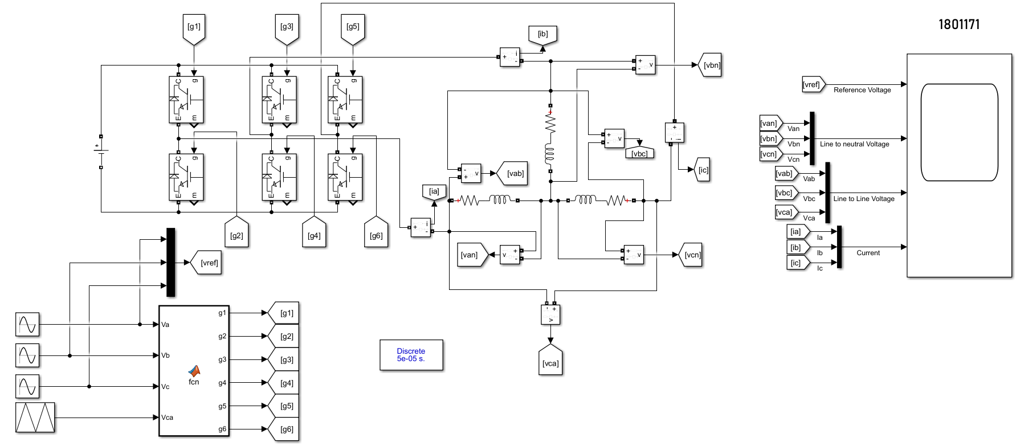**Block diagram**

Fig. 7.1: Block diagram for Three-Phase inverter

* 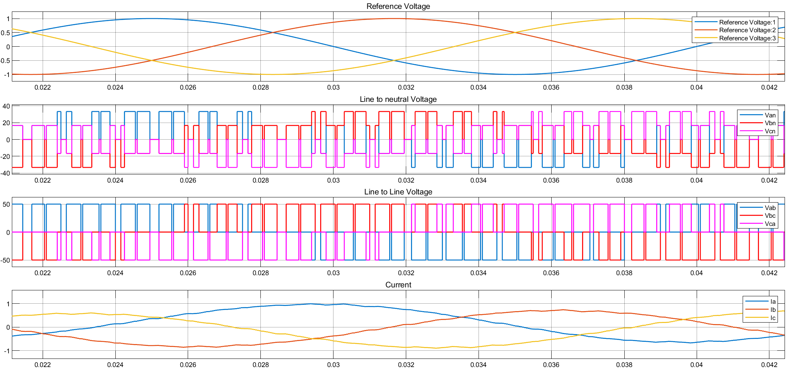**Waveform**

Fig. 7.2: Waveform for Three-Phase inverter

**Hysteresis control of grid connected single phase inverter**

* **Block diagram**

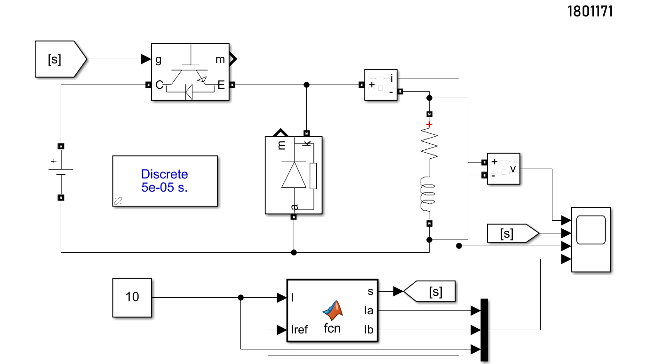

Fig. 7.3: Block diagram for hysteresis control of grid connected single phase inverter

* **Code for MATLAB function**

function [s,Ia,Ib] = fcn(I,Iref)

persistent d

if isempty(d),d=1;end

e=1

Ia=I+e;

Ib=I-e;

if Iref>Ia

d =0;

elseif Iref<Ib

d=1;

else

d=d;

end

s=d

end

* **Waveform**

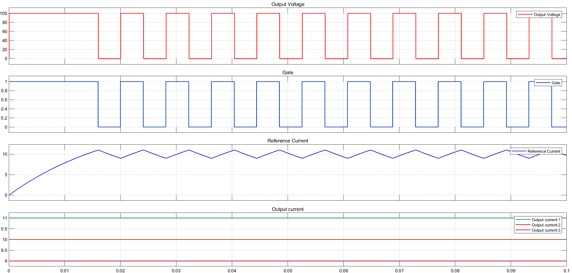

Fig. 7.2: Waveform for hysteresis control of grid connected single phase inverter

* 1. **Discussion & Conclusion**

This experiment thoroughly investigated three-phase and hysteresis control of grid connected single phase inverter. For three phase connection, we utilized Wy-delta connection according to our preference. Similarly for Hysteresis control inverter we used necessary tool according to our requirements. Thus, desired output was observed and the simulation was a success.